**DAILY ONLINE ACTIVITIES SUMMARY**

|  |  |  |  |  |  |  |  |  |
| --- | --- | --- | --- | --- | --- | --- | --- | --- |
| **Date:** | **11/06/2020** | | | | | **Name:** | **Spoorthi M S** | |
| **Sem & Sec** | **6th /B** | | | | | **USN:** | **4AL17CS097** | |
| **Online Test Summary** | | | | | | | | |
| **Subject** | | **PAP Assignment Test - 3** | | | | | | |
| **Max. Marks** | | **20** | | **Score** | | | **18** | |
| **Certification Course Summary** | | | | | | | | |
| **Course** | **Web Design** | | | | | | | |
| **Certificate Provider** | | | **Shaw Academy** | | **Duration** | | | **4weeks** |
| **Coding Challenges** | | | | | | | | |
| **Problem Statement:**   1. Python Program to find the average of all Items in a Dictionary 2. Write a python function that converts a string to all uppercase, provided it contains at least 2 uppercase characters in the first 4 characters. Else print the string as it is. | | | | | | | | |
| **Status: Completed** | | | | | | | | |
| **Uploaded the report in GitHub** | | | | | **Yes** | | | |
| **If yes Repository name** | | | | | <https://github.com/msspoorthi/onlinecoding> | | | |
| **Uploaded the report in slack** | | | | | **Yes** | | | |

**Online Test Details**

PAP Assignment Test 3 Details:

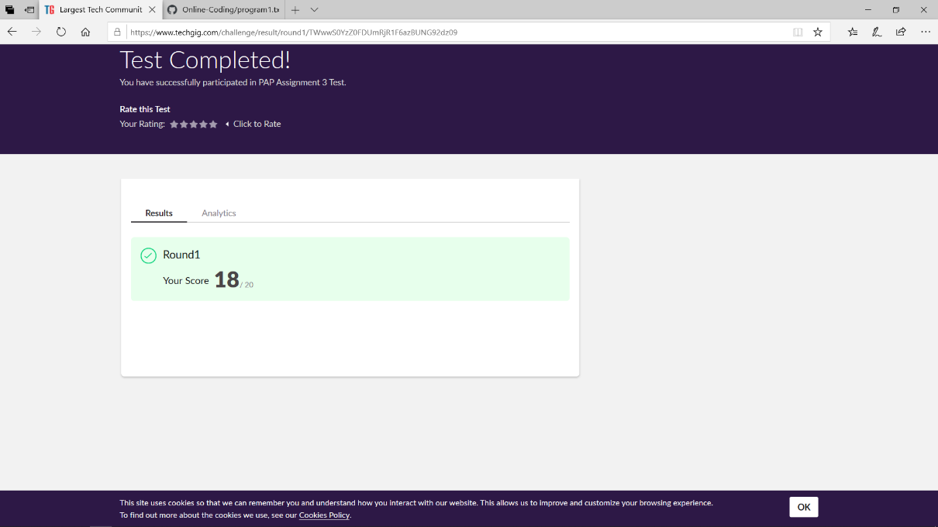

**Online Certification Details**

**Lesson**

* Digital CV Part 3



**Coding Challenge Details**

1. Python Program to find the average of all Items in a Dictionary

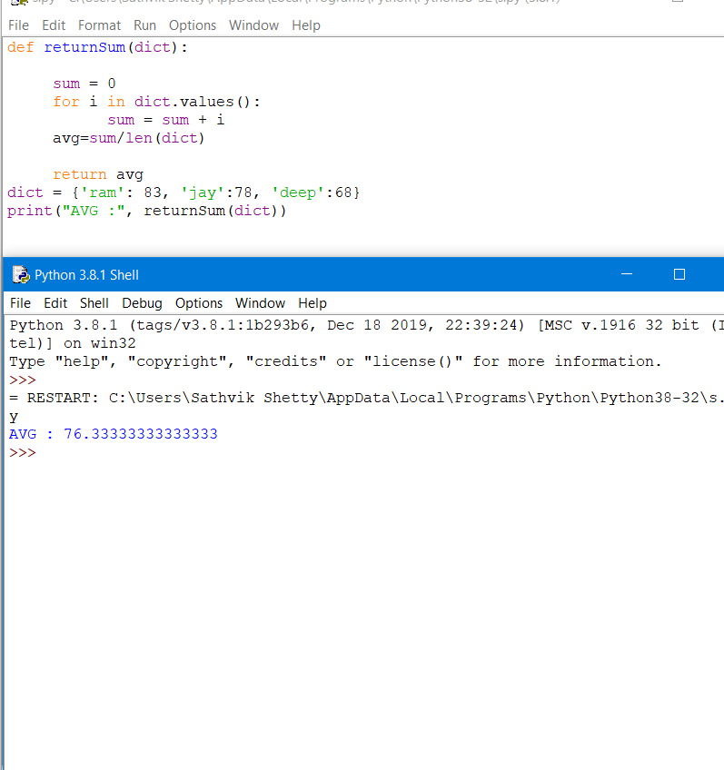

1. Write a python function that converts a string to all uppercase, provided it contains at least 2 uppercase characters in the first 4 characters. Else print the string as it is.

